**Assignment – 2**

**Data Visualization and Pre-processing**

|  |  |
| --- | --- |
| Assignment Date | 22 September 2022 |
| Student Name | Mr. P .Aravinth |
| Student Roll Number | 142219106011 |
| Maximum Marks |  |

**TASKS:**

1. Download the dataset

1. Load the dataset

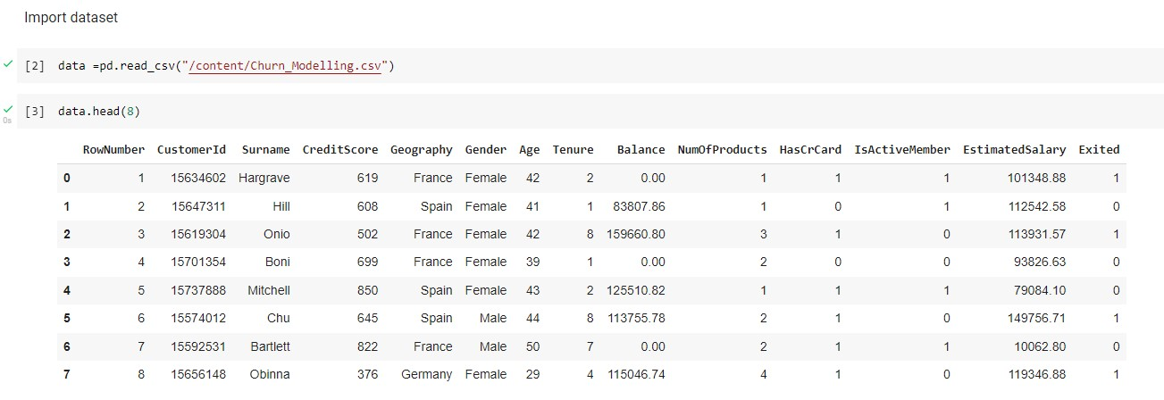

1. Perform Below Visualizations.
   * Univariate Analysis

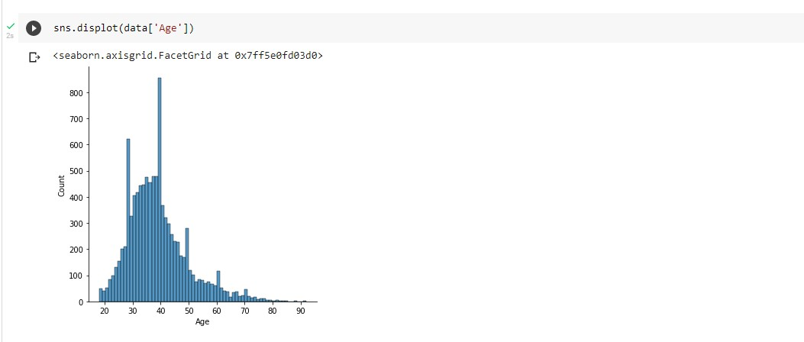

* + Bi-Variate Analysis

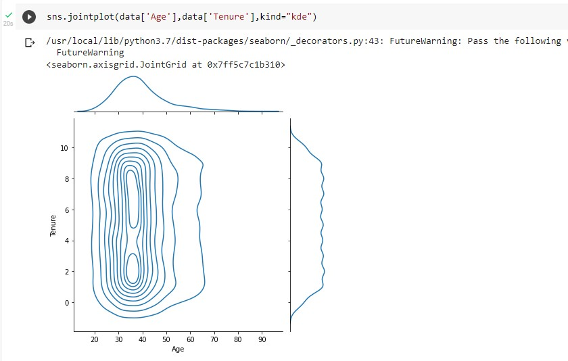

* + Multivariate Analysis

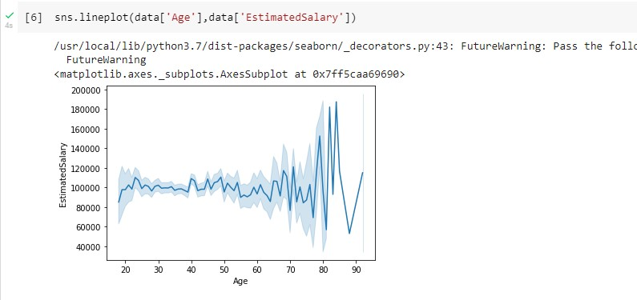

1. Perform descriptive statistics on the dataset

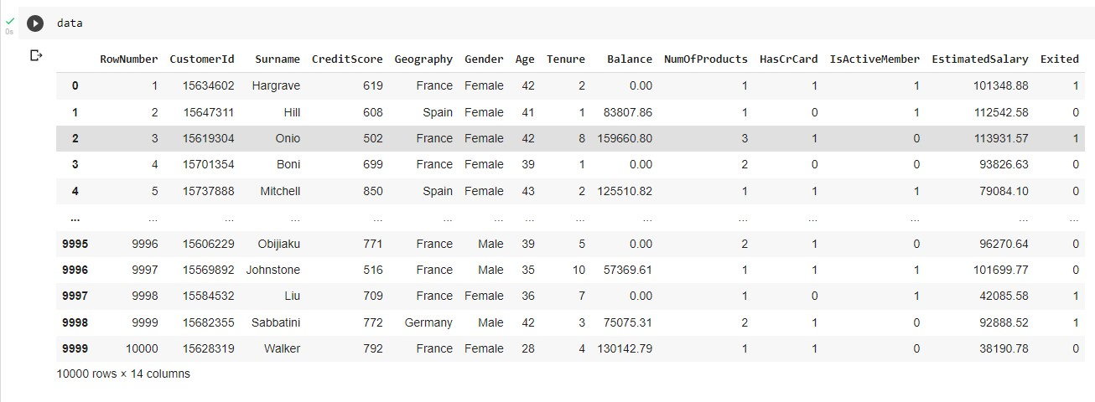

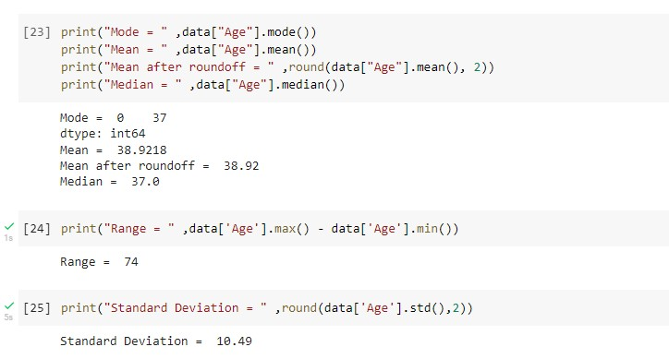

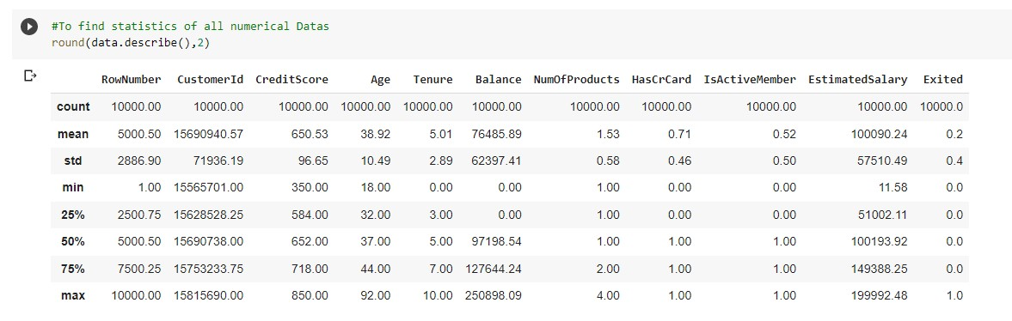

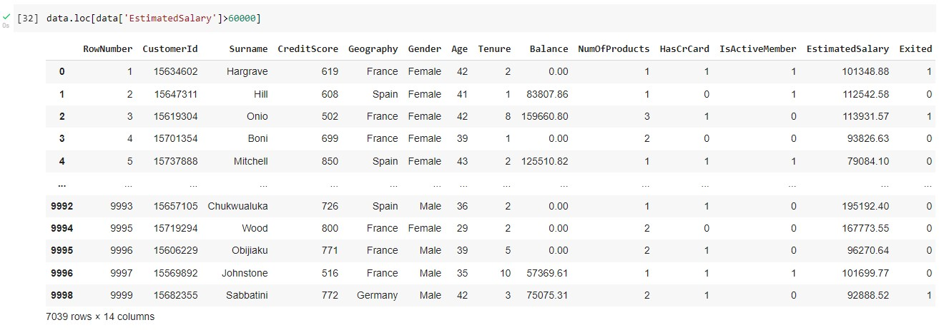

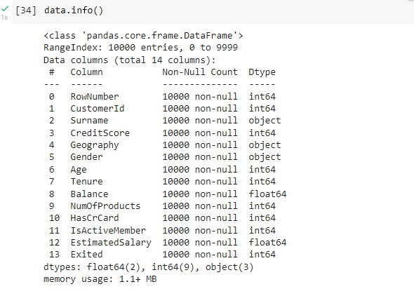

1. Handle the Missing values.

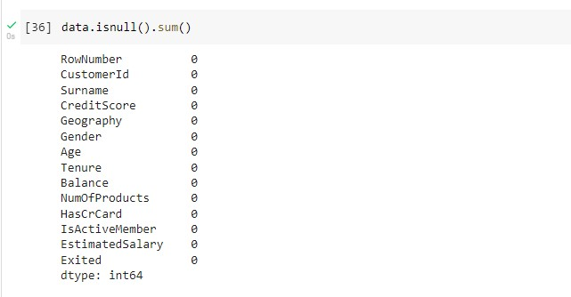

# 6. Find the outliers and replace the outliers

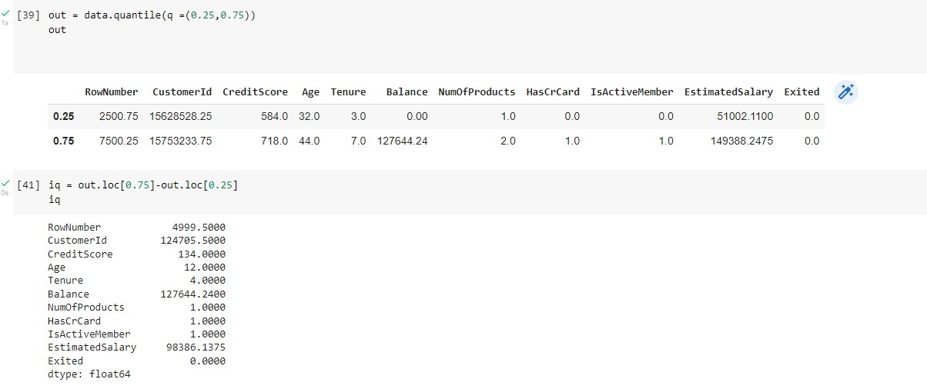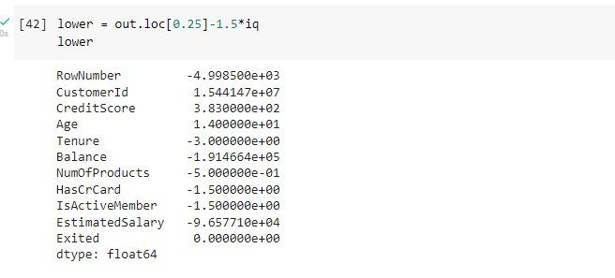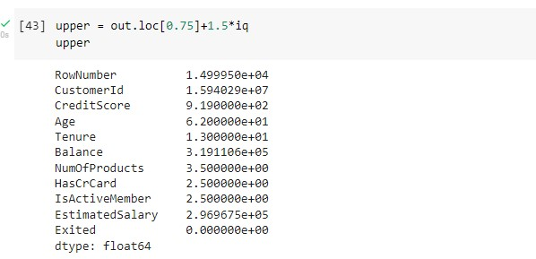

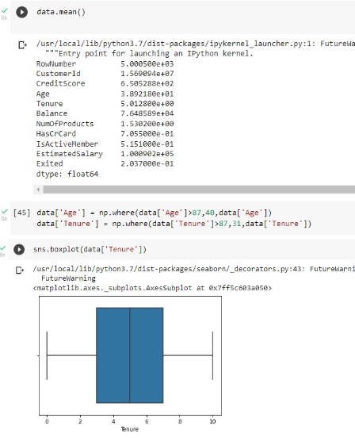

1. Check for Categorical columns and perform encoding.

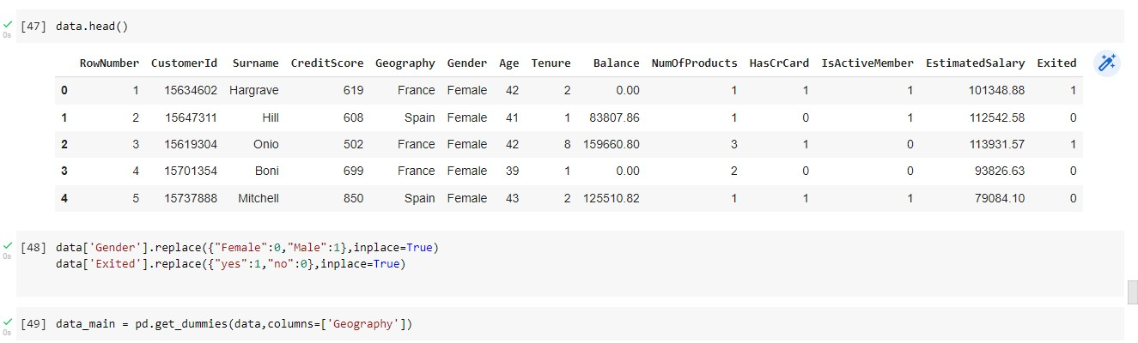

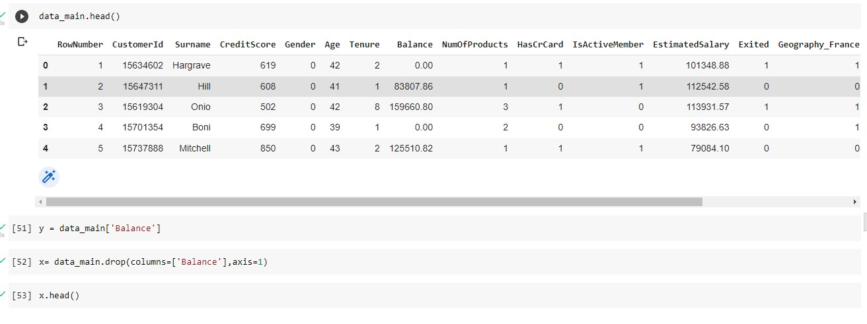

1. Split the data into dependent and independent variables.

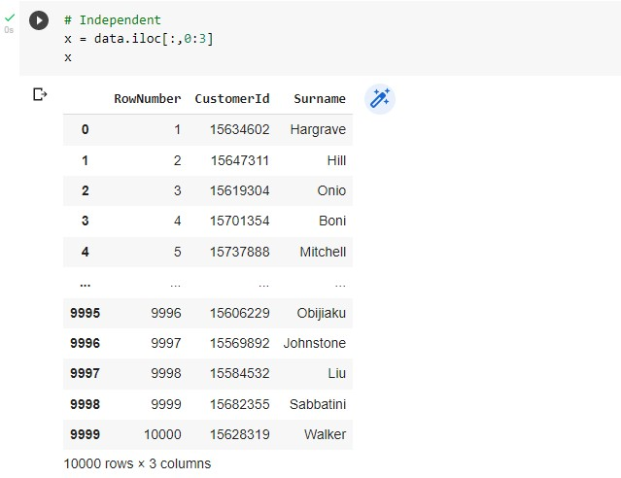

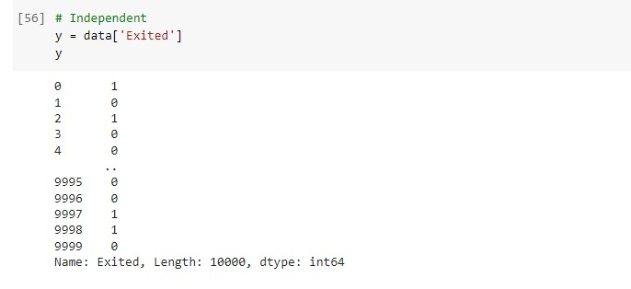

## 9. Scale the independent variables

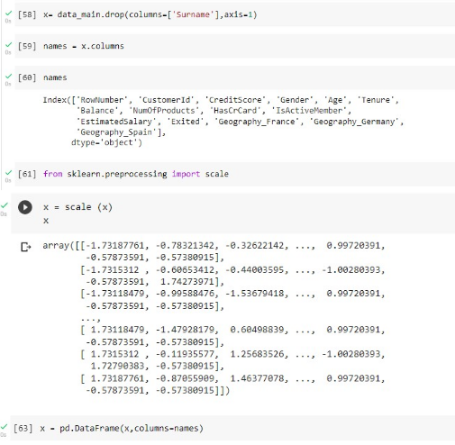

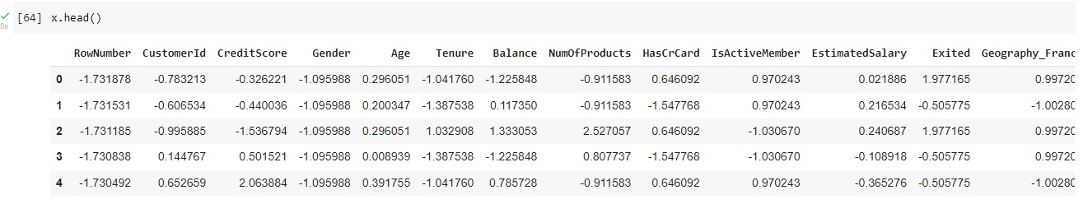

## 10. Split the data into training and testing

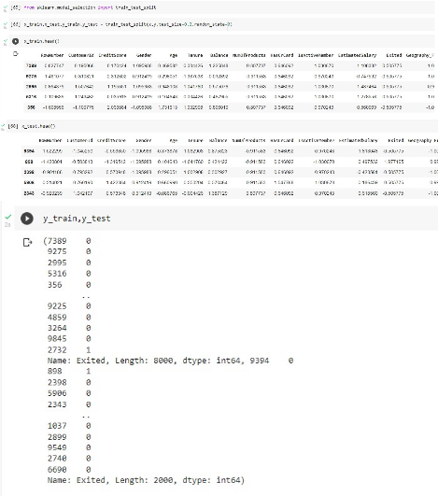

**COLAB LINK :**

https://colab.research.google.com/drive/1v5GSQB_R4UiRDTSUiZZweKCYpPN2nblT#scrol lTo=eyzUNIQQvCza